## Kit Contents

|  |  |
| --- | --- |
| 1 x Raspberry Pi Computer (in a case) | 1 x Keyboard with USB Dongle |
| 1 x Robot Chassis | 2 x Motors and Wheels |
| 1 x Motor Controller | 1 x Battery Box |
| 1 x Power Brick | 4 x AA Batteries |
| 1 x Roller Ball | 1 x Screwdriver |

## tinyrobots/shutterstock_322216877-1-3.pngInstructions

**Step 1**

Decide on a name for your robot  
Write it here:



**Step 2**

Stick double-sided tape to the two motors  
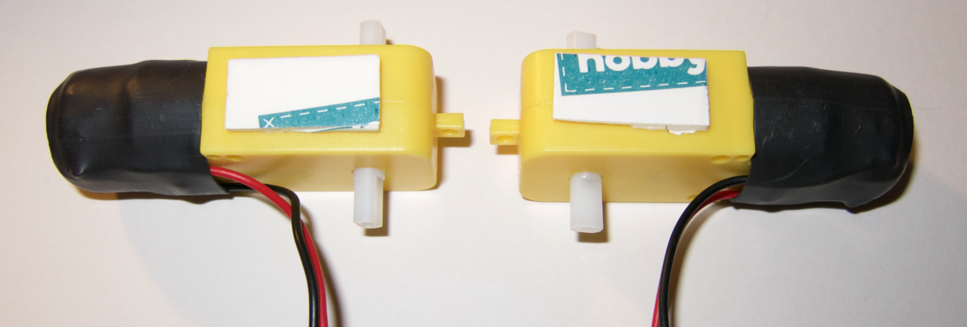  


**Step 3**

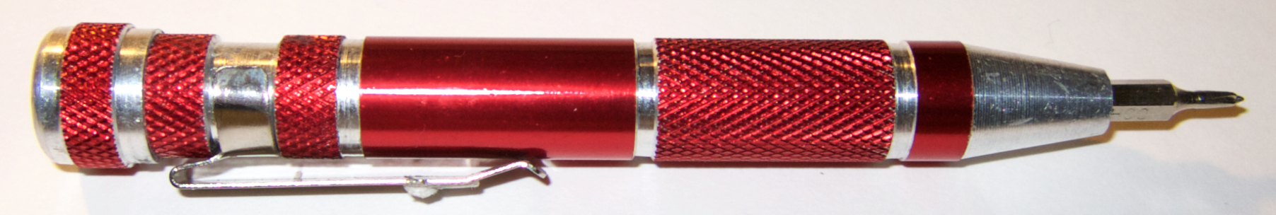Connect the motors and battery box to the controller board using the screwdriver  
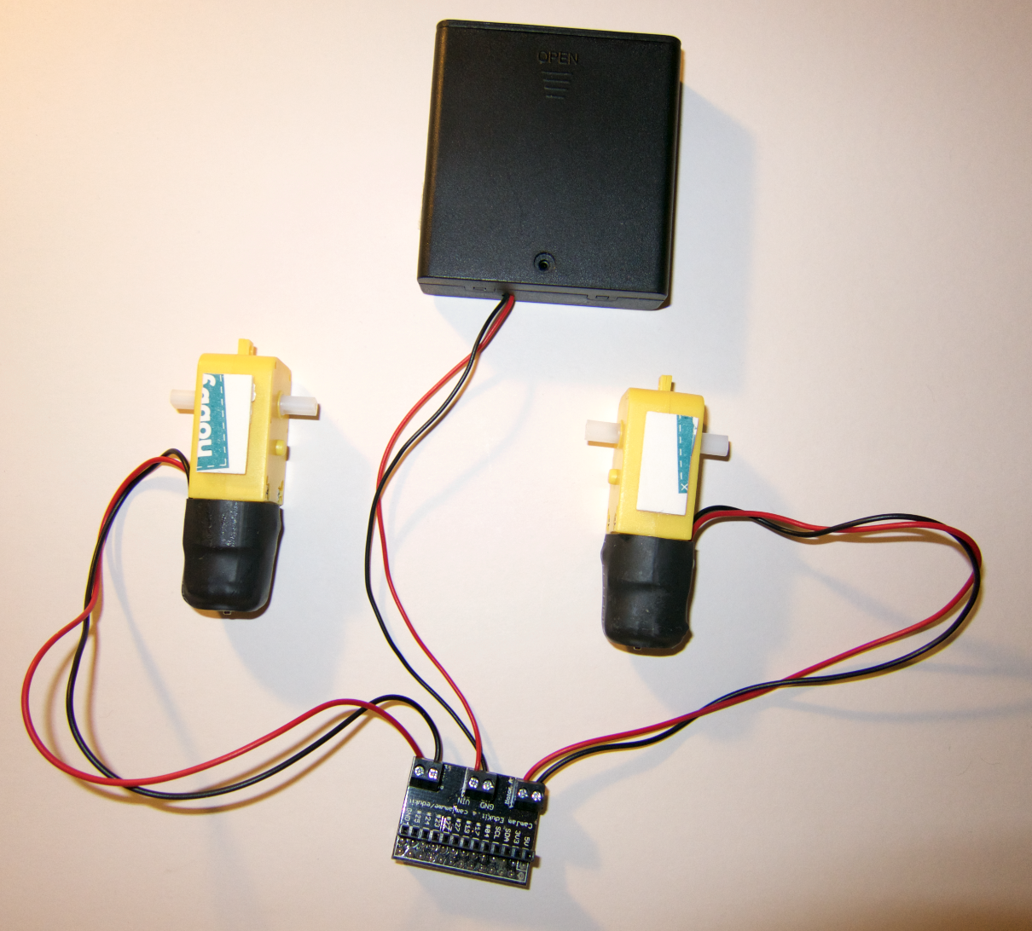  
make sure that red and black are the right way around  
VIN = red GND = black  
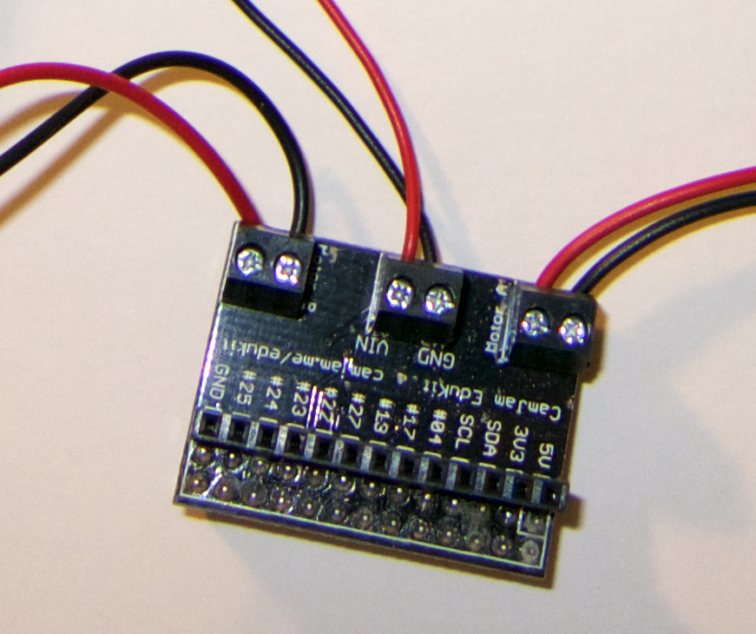

Battery

Box

Right motor

Left motor

**Ask for help if you need it!**



**Step 4**

Install the motors in the robot chassis by sticking them down with the double-sided tape.

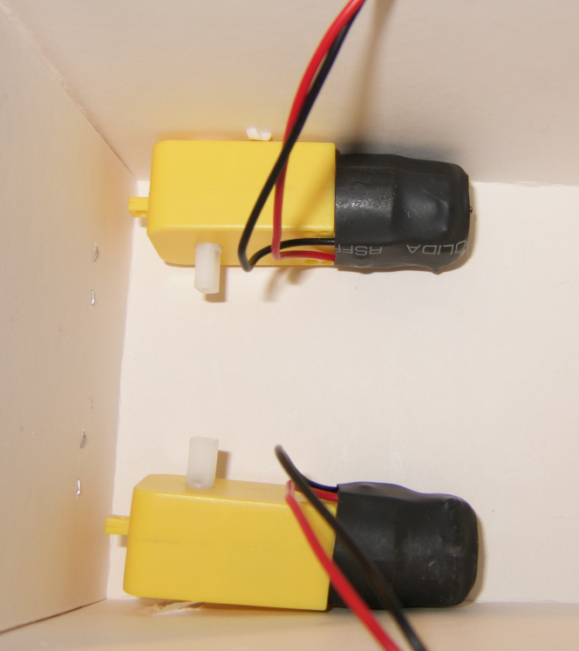

Make sure that the motor spindles stick out through the holes in the box.

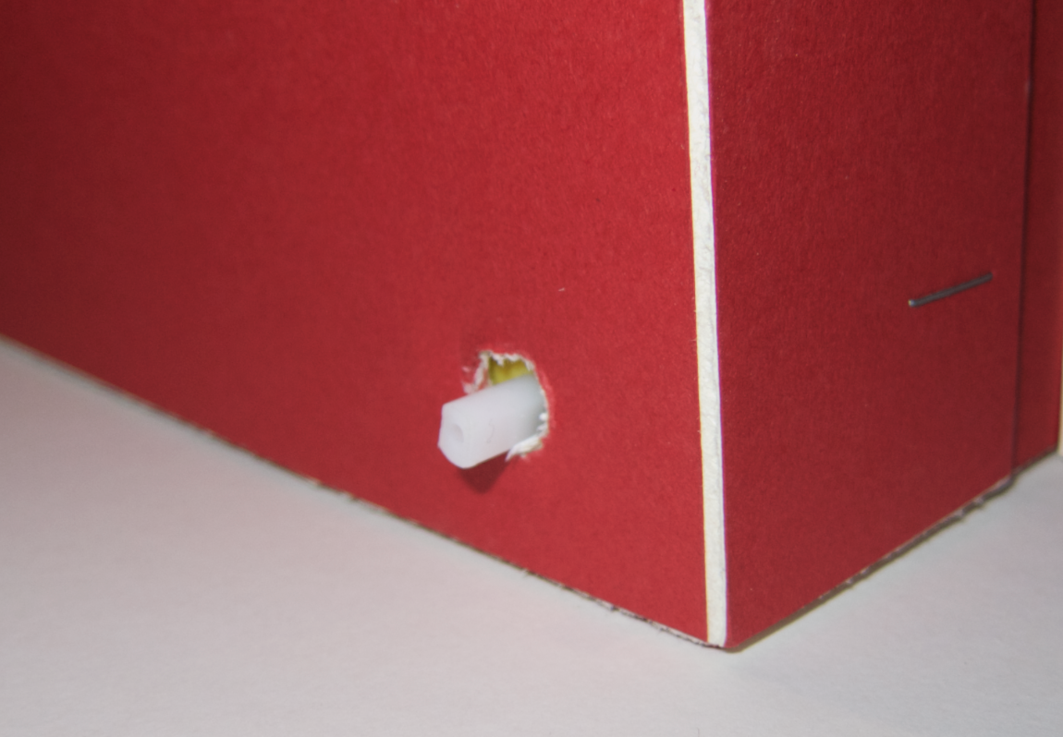

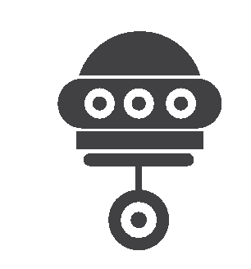

**Step 5**

Attach the wheels by pushing them on to the motor spindles

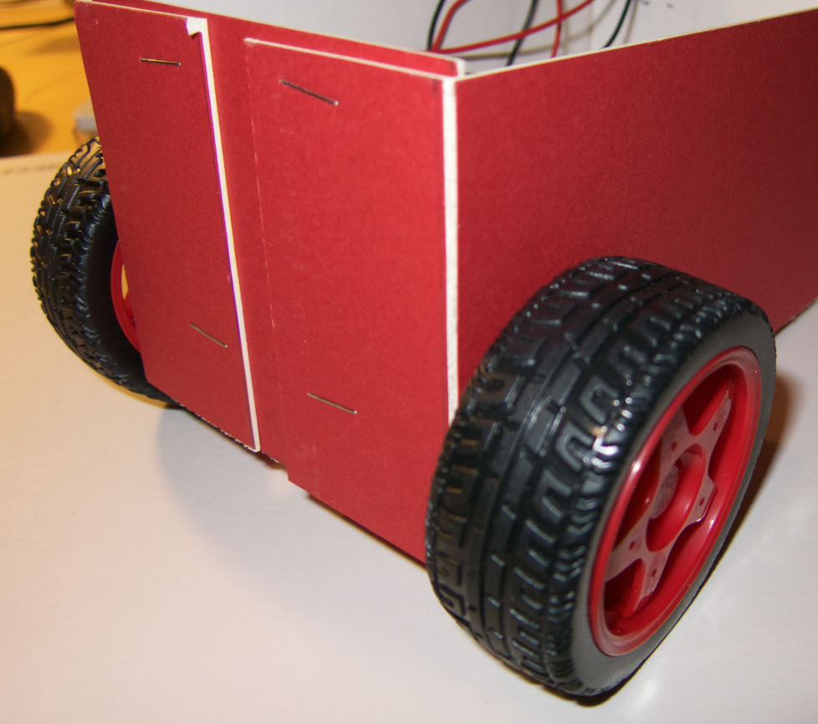

**Slowly turn the wheel round whilst pushing gently so that it slides on when in the right position**

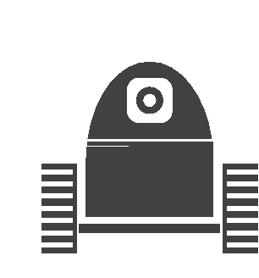

**Step 6**

Use double-sided tape to attach the roller ball to the chassis at the opposite end from the wheels.  
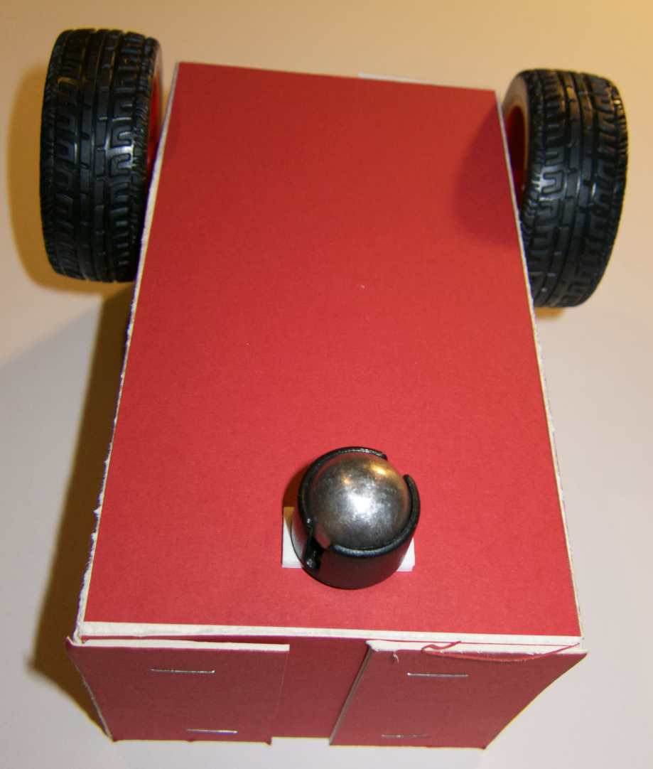

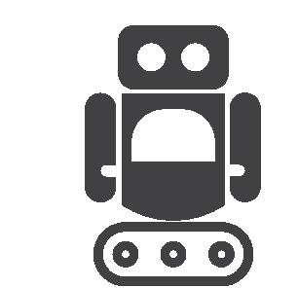

**Step 7**

Attach the controller board to the Raspberry Pi  
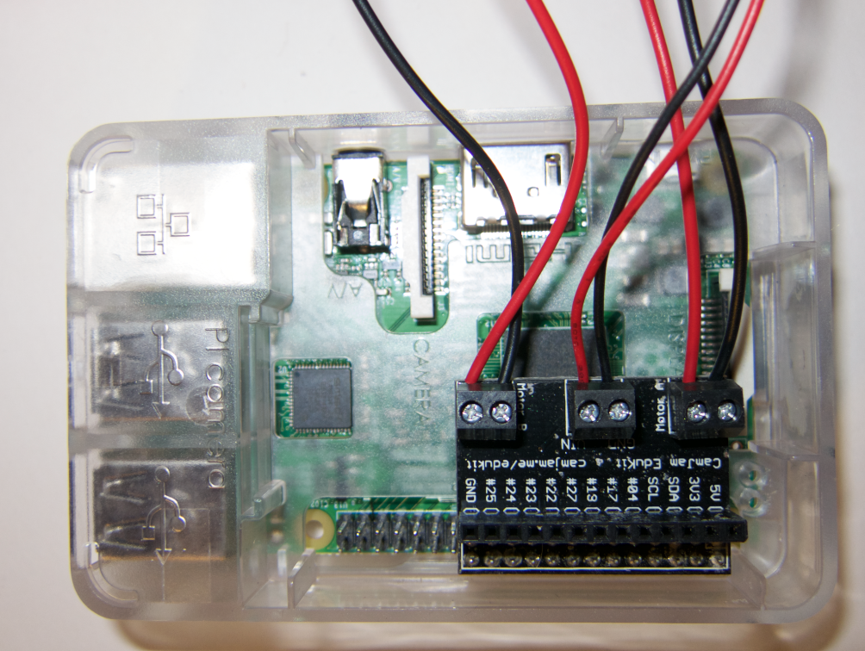

**This is tricky so ask for help connecting it!**



**Step 8**

Insert the AA batteries into the battery pack

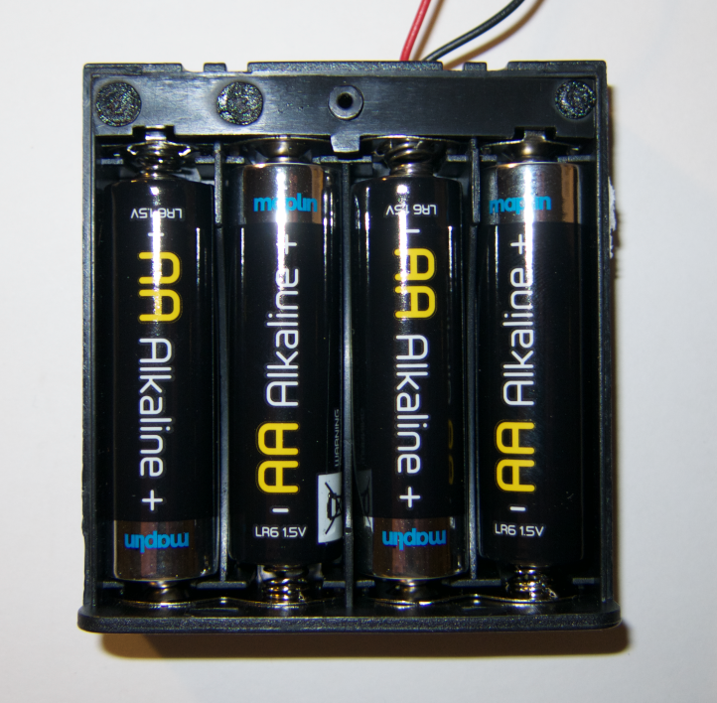

Slide the power switch on the battery box to the “on” position

**Step 9**

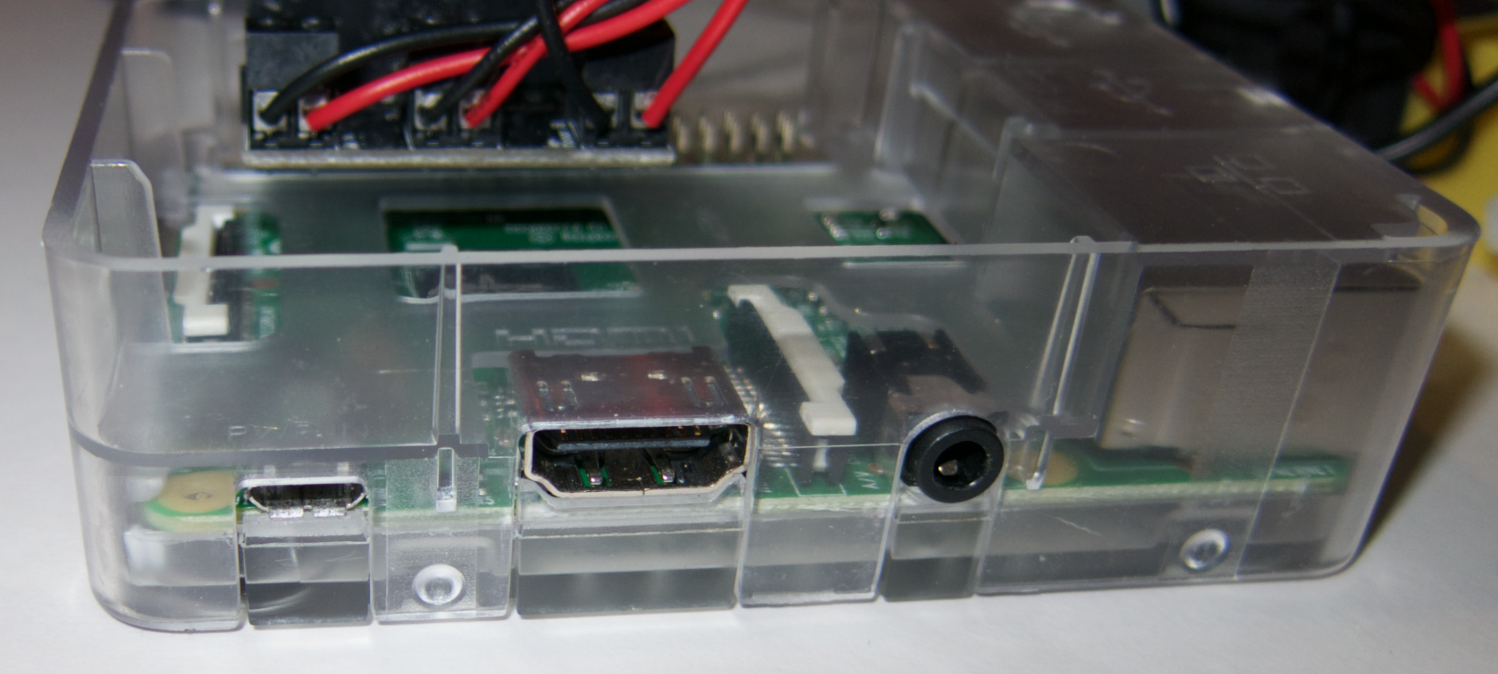Connect the Power Brick to the Raspberry Pi here  
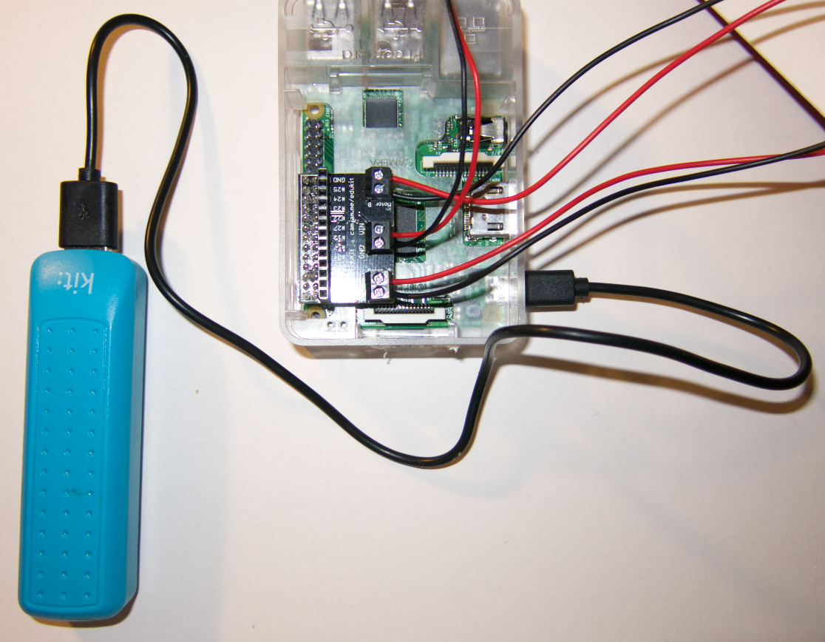

A red light should light up on the Raspberry Pi



**Step 10**

Switch on the wireless keyboard by sliding the switch at the top

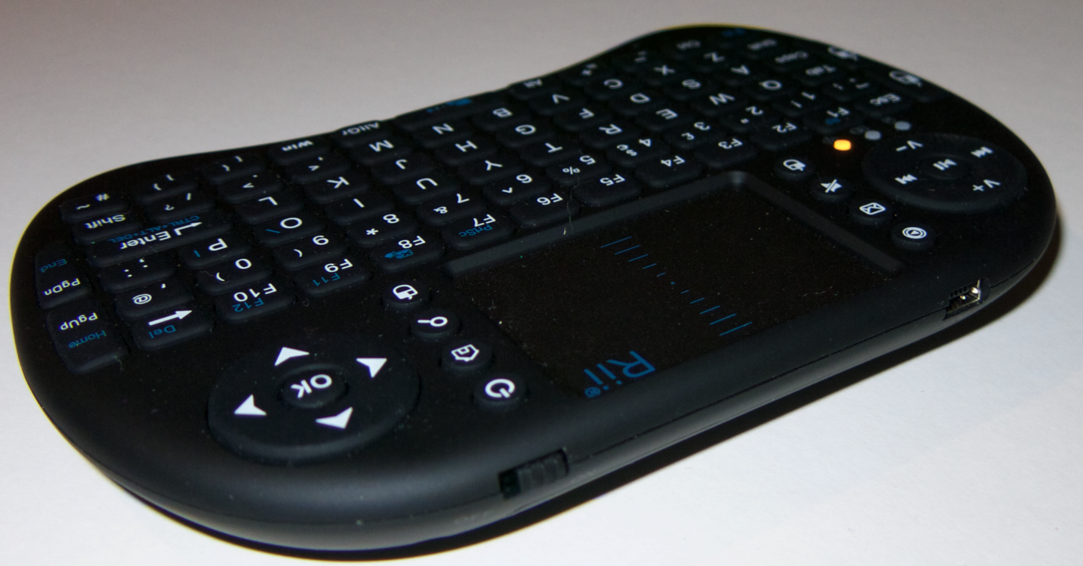

A yellow light should start flashing. This will turn blue when the keyboard has connected to the Raspberry Pi



**Step 11**

Fit everything into the cardboard chassis.

Now test your robot!

Push the arrow keys on the keyboard to make it go.

Make sure forward, backward, left and right all work.

Test driving it and get good at making it go where you want it to.



**Step 12**

Decorate your robot.

Think about the name you’ve given it.

Make it look good.

When you are done make sure it still goes properly

**You are now ready for the challenges!**